**Project Design Phase-II**

**Data Flow Diagram & User Stories**

|  |  |
| --- | --- |
| **Date** | 24-06-2025 |
| **Team ID** | LTVIP2025TMID53914 |
| **Project Name** | **DocSpot:** Seamless Appointment Booking for Health |

**Data Flow Diagrams:**

A **Data Flow Diagram (DFD)** illustrates how data moves within the Freelance Finder platform. It captures how users (freelancers and clients) interact with the system, how information flows between different components, and where the data is stored.

📘 **DFD Components Explanation**

1. **External Entities**:

These are users who interact with the system from outside.

• Patient

* + - Initiates user authentication to log in. o Can book an appointment.
    - Has the ability to view appointments and access emergency services.

• Doctor

* + - Also goes through user authentication. o Provides their specialization.
    - Can view bookings.

1. **Processes:** 
   * User Authentication

Central login system validating both doctors and patients before giving access to services.

* + Book Appointment

Triggered by a patient. Sends appointment data to be stored/viewed.

* + Specialization

The doctor’s area of expertise is captured here and is likely used for filtering or matching with patient needs.

* + View Bookings

Doctors use this to see their scheduled appointments.

* + Emergency

Possibly a dedicated feature for patients to request urgent care.

* + Remove User

Admin has the authority to remove user accounts.

1. **Data Stores / Internal Actors:**

• Admin

* + - Accesses and views data. o Has control over user management (remove user). o Possibly monitors appointments or emergency cases. 🧩 **How Data Flows**
  1. Patient → User Authentication → Admin
     + Patient logs in, admin validates or manages access.
  2. Patient → Book Appointment → View → Emergency
     + The patient books an appointment, views it, and can access emergency if needed.
  3. Doctor → User Authentication → Specialization → View Bookings
     + Doctor logs in, updates specialization, and views their bookings.

1. Admin → View → Remove User

o Admin oversees all views and can remove users when needed.

🧩 **Observations / Suggestions for Improvement**

* 1. **Label Data Flows Clearly:** 
     + Arrows can be labelled with data descriptions (e.g., "login credentials", "appointment details") for clarity.
  2. **Add Data Stores:** 
     + Add boxes labelled Databases (e.g., User DB, Appointment DB) to show where data is stored.
  3. **Separate Processes and Entities Visually:** 
     + Use different shapes (e.g., circles for processes, rectangles for entities, open-ended rectangles for data stores).
  4. **Clarify Emergency Flow:** 
     + It’s unclear if the emergency data goes to a doctor, hospital, or alert system.

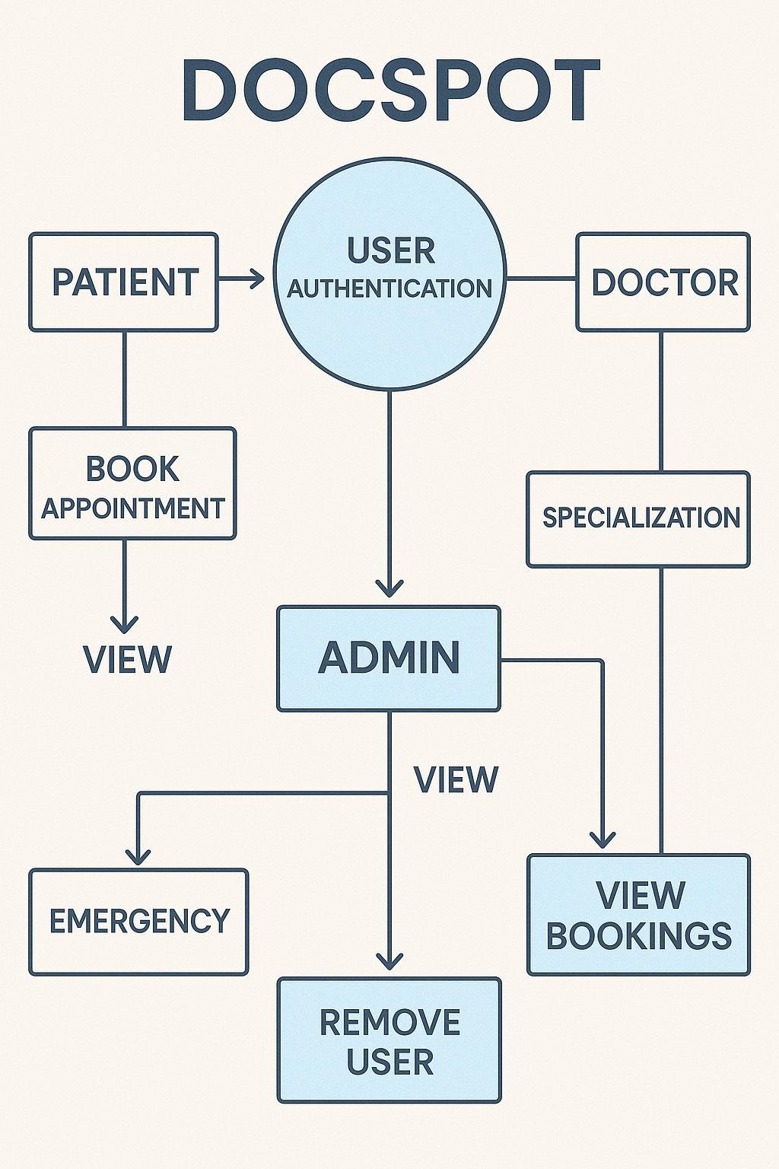

# User Stories

**User Story Table – DocSpot**

|  |  |  |  |  |  |
| --- | --- | --- | --- | --- | --- |
| **User Type** | **Functional**  **Requirement**  **(Epic)** | **User Story / Task** | **Acceptance Criteria** | **Priority** | **Release** |
| **Patient** | Appointment  Booking | As a patient, I can search for doctors by specialty and location. | Search results return relevant doctors. | High | Sprint-1 |
|  |  | As a patient, I can book, reschedule, or cancel appointments. | Appointment status updates accordingly. | Medium | Sprint-2 |
| **Healthcare**  **Provider** | Schedule  Management | As a provider, I can manage my availabi calendar. | Changes reflect immediately in patient booking system. | High | Sprint-1 |
| **User** | Messaging | As a user, I can chat with the other party in real-time. | Messages appear instantly. | Medium | Sprint-2 |
| **Admin** | Profile  Management | As a Admin, I can update my profile. | Changes are saved successfully. | High | Sprint-2 |
| **Client** | Payment Processing | As a client, I can make secure payments after job completion. | Payment recorded and shown in transaction history. | High | Sprint-2 |
| **user** | Review System | As a user, I can leave a review after project closure. | Review appears on profile. | Medium | Sprint-2 |
| **Admin** | User Moderation | As an admin, I can review reported users and take action. | Reports and actions logged. | High | Sprint-1 |